November 18, 2018 – Temp 35, rainy, slushy, snowy. I still need to rake the leaves as they are still falling from the trees, which is very late this year.

We are looking forward to our amazing 16th anniversary on 11/29, right after this year’s amazing Thanksgiving holiday.

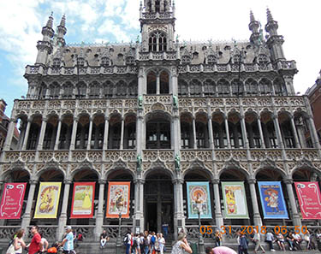It was another year of weddings, births, anniversaries and deaths, we celebrate and mourn and remember; we again are thankful for all our blessings.

Our grandkids seem to be doing fine. They are finding their way in the world and learning valuable life lessons along the way. The younger one’s are pushed and pulled from one thing to another and they are constantly bombarded with new experiences daily. I think too much stimulation and not enough down time.

We did a lot of traveling this year with trips to Amsterdam, Antwerp, Brussels, and Paris in May, where w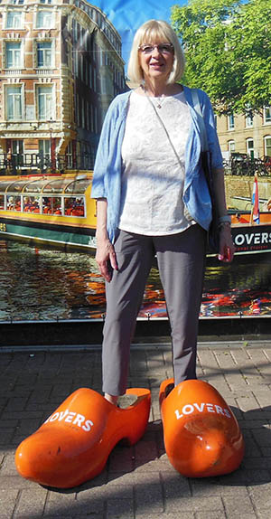e found the people nice and the country very hospitable. Visited the windmills, art museums and walked many a mile thru the streets and canals. We try to pack a lot of stuff into the vacation and they can be hectic, but great all the same. I took a short trip to Springfield, MA to see the largest train show in the US (it was). A trip to Las Vegas where we visited the Pawn Stars shop and made a purchase of an original Mark Chagall lithograph. The pawn shop looks bigger on TV. Then, I took a trip to Washington State to visit my son Ben, Robin, Ben, Sam & Olivia. It was a great trip with much to see and do. Check out the photos and video on facebook. During June we had Abree, Caleb & Bryson from Dallas for a week. Caleb, Donna & Bryson are lower right. Abree was with her other grandparents. Ben & Olivia are in photo right. Sam was in Iceland.

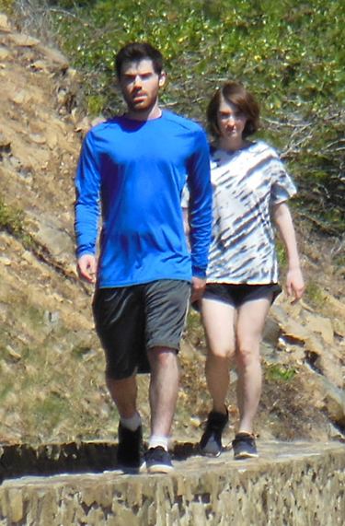

Donna has been busy as ever with nursing in the 21st century. She gets the highest marks in patient satisfaction; constantly, it’s so boring! Her Shaklee business continues to thrive, occupying most of her free time.

It’s official I am retired! I know that may come as a shock to most of you, who think I haven’t done anything in years, and others who may say “What?” but yes, we put the apartment on the market and it sold in just a couple of weeks. I no longer have to take care of a building and the people in it. It is so nice to not be on call 24/7.

Donna has kept me busy installing a hardwood floor in our bedroom, framing several pieces of artwork from our travels and hanging out together.

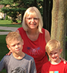Memories: The kids that lived in our neighborhood were like family. We knew their names, their birthdays and their pet’s names. We did everything together, from riding our bikes all day till dark literally, to having Monopoly game tournaments. We were in the Boy/Girl Scouts with most. Went hiking, played baseball, and football, climbed trees, got hurt, built forts, played in the dirt. I think we were the last generation to actually play marbles. Where we played for “keeps”. If you knock the opponents marble out of the ring you got to keep it. You cried when a friend(s) moved away. Made friends with the new kid on the day they moved into their house. And, at Christmas, when visiting them, you yelled “What did you get?! What did you get??!”

To you, our family, our friends, with love, respect and admiration, we wish you a wonderful holiday season, and a happy, healthy, New Year! So, until next year…we wish you and yours the very best life can offer.

Ben & Donna